**Impact Reporting for Food Club Dataset**

Flow of the page:

1. Introduction about the “BS3 Community Food Club” (A simple and brief paragraph).
2. Venn diagram showing the 3 main goals of this initiative (Clickable throughout).
3. The nutrition part leads to a page showing the amount and variety of food provided in this initiative till date (Average or total sold).
4. The environmental part leads to a page which effectively shows the disposal techniques employed by BS3 Community.
5. The building a community part shows attendance numbers growth, cost and the other people related metrics.

**Introductory paragraph draft:**

“The BS3 Community Food Club is a dynamic network dedicated to fostering nutritional, environmental and community wellbeing across Bristol. By offering fresh, nutritious food, we support the economic sustainability of the community we serve. Operating from key locations like Bedminster, Speedwell, Redcliffe, Hartcliffe, and St Pauls, the Food Club is at the forefront of addressing food security, promoting sustainable and cost effective living within our city.”

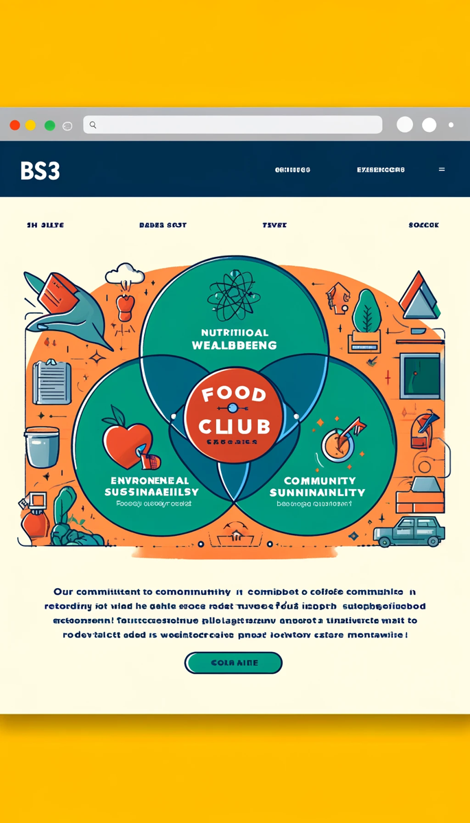

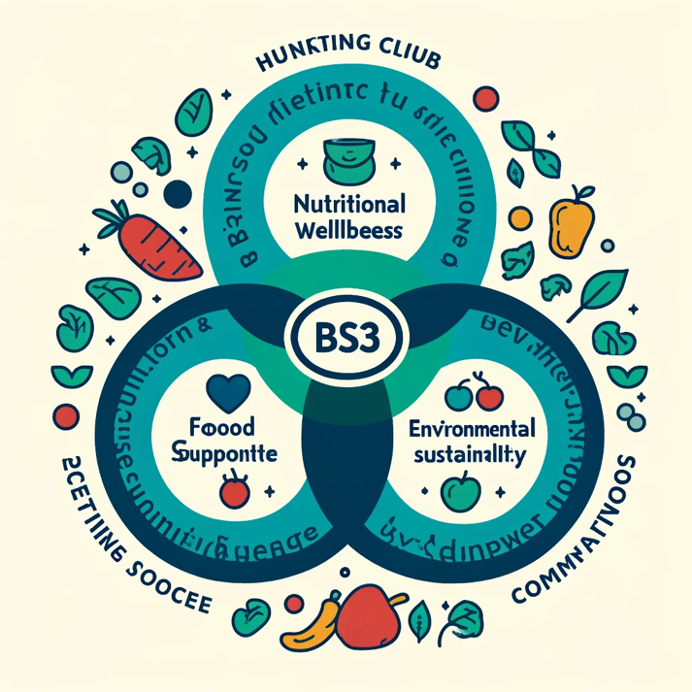

**Nutritional Wellbeing:**

* 220 bags average monthly (Icon)
* Graph to show the growth of bags sold (Graph)
* 1538 bags from August 2023 till date (Icon)
* **“X kgs”** provided from August 2023 till date (Icon)
* **“Y”** types of vegetables offered (Icon)
* Add different types of food items available on top of the truck e.g., Carbohydrates: 38% Fruit and vegetables: 40% Dairy and alternatives: 8% Protein: 12% Oils and spreads: 1% etc.
* Access to a list of vegetables and tinned food items provided.
* Cost saving infographic included also in the introductory paragraph of the page.
* Paragraph: The BS3 Community Food Club is at the forefront of promoting nutritional wellbeing, offering substantial cost savings on quality food. Our program, with food bags worth £10-£15 available for only £4, not only makes healthy eating more affordable but also reflects our growth—with an increasing number of bags sold symbolizing a widening community impact.

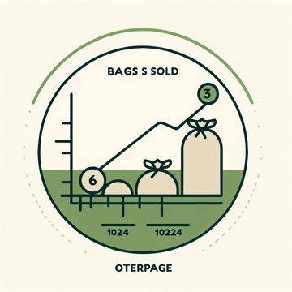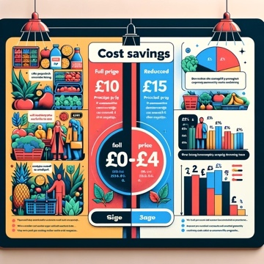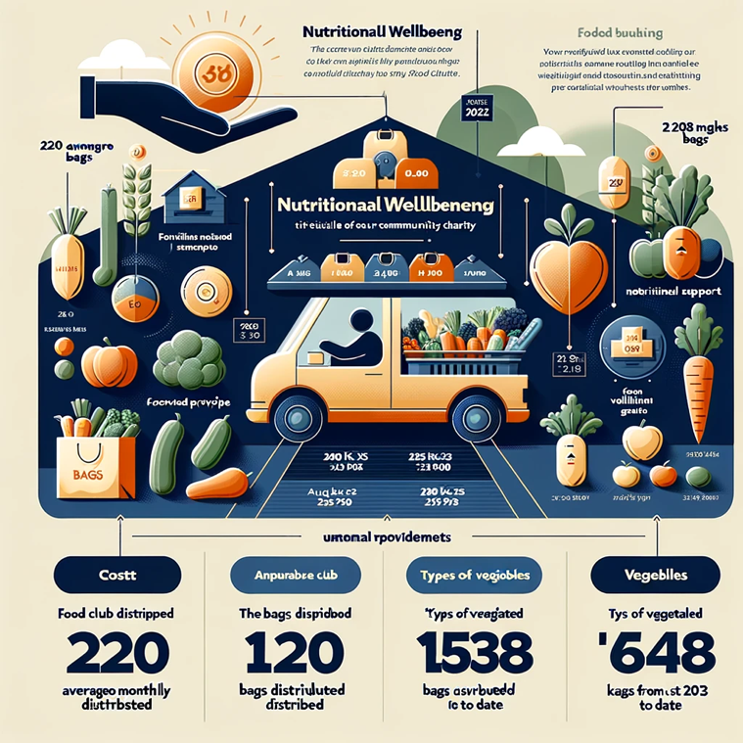

**Environmental Sustainability:**

* Should contain a whole Lifecyle of products.
* From acquiring and mentioning your partners to distribution and your centers where you host this initiative and finally your disposal tactics.
* Can mention how not much is left to show further impact nutrition wise.
* Introductory paragraph draft: Our Food Club embraces a sustainable approach at every step. We begin with mindful **acquisition**, partnering with local producers committed to quality and eco-friendly practices. In **distribution**, our network of centers becomes a hub for community nourishment, where fresh, nutritious food reaches those who need it most. Finally, our **disposal** tactics ensure minimal waste, as we cleverly repurpose or recycle any excess, reflecting our dedication to the environment and community health. Each phase of our cycle is designed to strengthen community ties and sustain our planet.

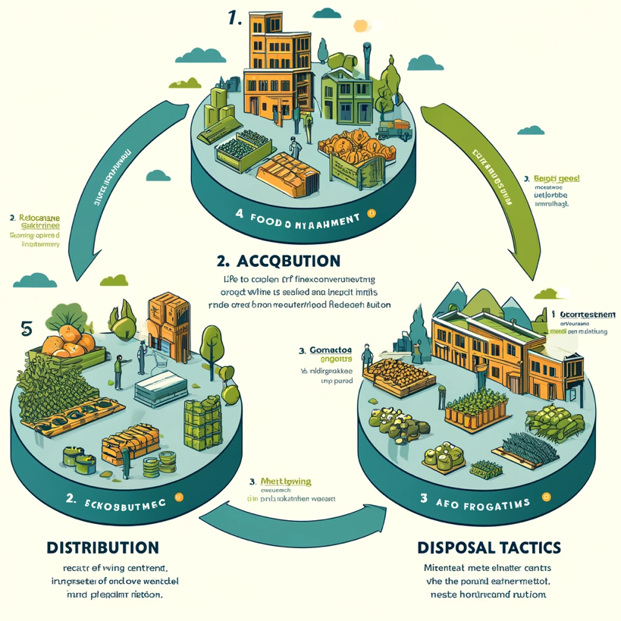

**Community Support and Interaction:**

* Trend Graphs and Turnup rates for predicted values as well.
* Trend Graphs and Revenue growth for predicted values as well.
* Savings Icon to show how much saving has been done according to a price difference of 8.5 pounds per bag on an average.
* Paragraph draft: The BS3 Community Food Club is a testament to the strength and unity of our community. With a steady increase in participation—from an average of 200 members monthly in 2021 to an anticipated 300 in 2024—our trajectory speaks to the tangible impact of our initiatives. Financially, the growth is equally telling, with annual revenues climbing by 25% over the same period. Our approach to affordability has led to community savings of over £30,000 annually, illustrating the value of our £4 food bags, which consistently exceed a £10 value. This success is a shared journey, reflecting the collaborative spirit that is the hallmark of BS3 Community

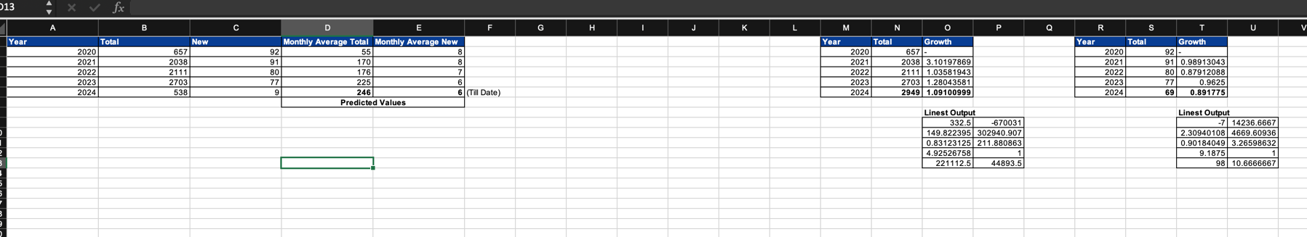

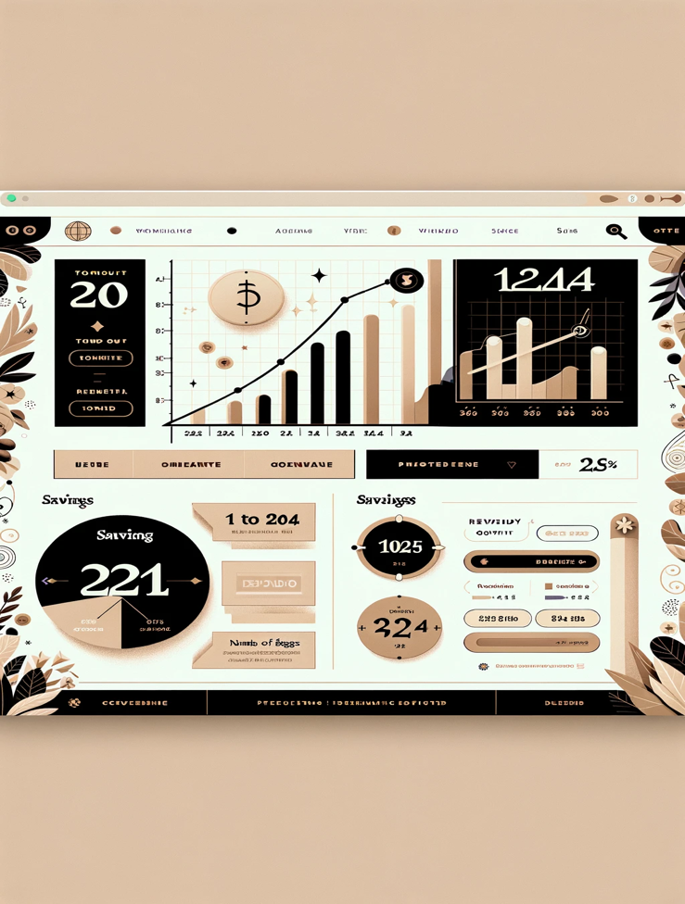

**Impact Reporting for Social Prescribers Dataset**

Flow of the page:

* Introductory paragraph on the bottom of the page as shown in two phases.
* First phase about what this initiative does.
* Second phase about aims and goals.
* On the very bottom the types of cases you have handled with icons as shown in the image (Clickable throughout for testimonials belonging to each type of case)
* One of the graphs on top would show the growth in the number of social prescribers alongside with the icon for ‘Bridge View Medical’.
* The other growth graph would be about the increase in number of people you have helped (M-o-M average numbers).
* Third will be an interactive graph about the demographic distribution of the people this initiative has served (showing the range most importantly 12-101).
* The top part with images would be the pre and post metrics alongside with a thematic analysis and some testimonies.
* The themes would be in a roadmap depicted with smart icons (Clickable throughout).
* There will also be some overall KPIs like total number of people served (161)/ Number of visits till date (420), number of hours spent helping, how many months or years this initiative has been running for etc.
* Paragraph phase 1 draft: The Social Prescriber Initiative stands as a cornerstone for community health, delivering tailored support to individuals facing a spectrum of challenges. In collaboration with Bridge View Medical, this initiative ensures that professional guidance is accessible for concerns ranging every aspect of wellbeing there is.
* Paragraph phase 2 draft: With a mission to heal and connect, our goals are ambitious yet fundamental: foster stronger community bonds, make accessible for all, and enhance overall physical and mental wellbeing. We stand as allies, guiding our community to a more supported, healthy, and interconnected future.

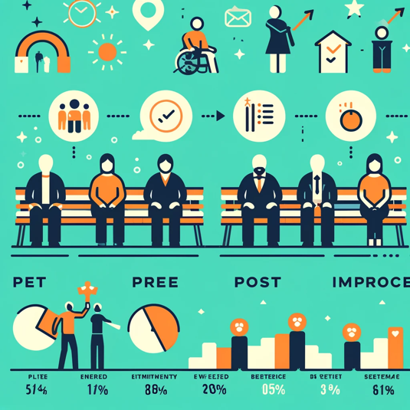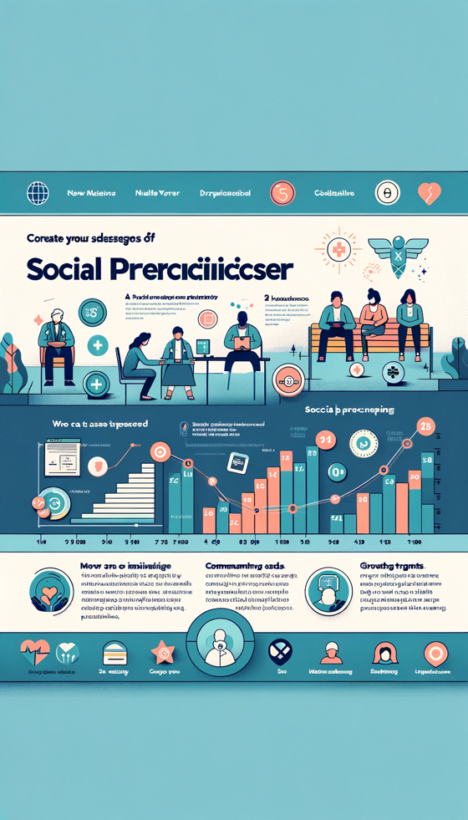

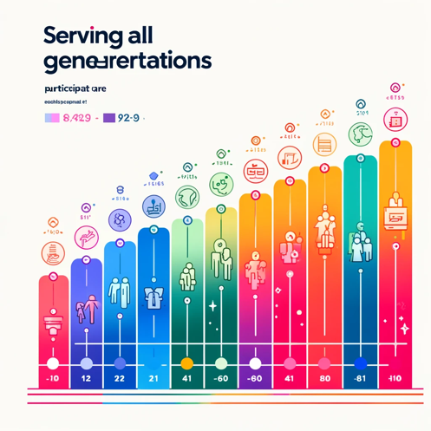

* Some opensource tools to help do thematic, sentiment and other Natural Language Processing (NLP) tasks are:
  1. **NLTK (python)**
  2. **Gensim**
  3. **Voyant Tools**
  4. **KNIME**
  5. **TextBlob (python)**
  6. **RapidMiner**

**Impact Reporting for Square Sales Dataset**

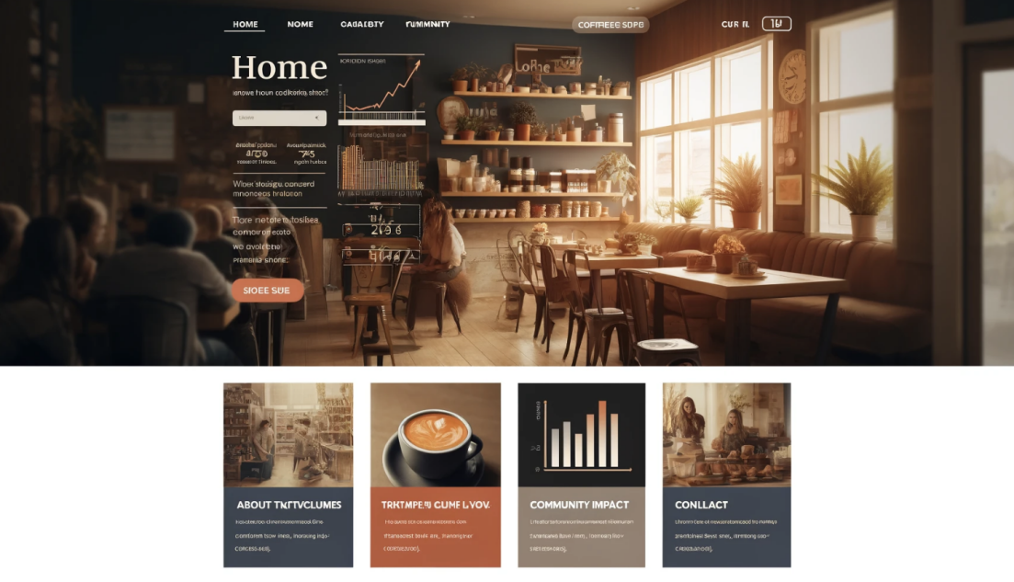

**Introduction**

This report is based on the analysis of the daily transaction number of a coffee shop in the BS3 community. It explores how the coffee shop can improve the emotional, social, physical and It has a positive impact on the community in many aspects.

**Daily Transactions Analysis**

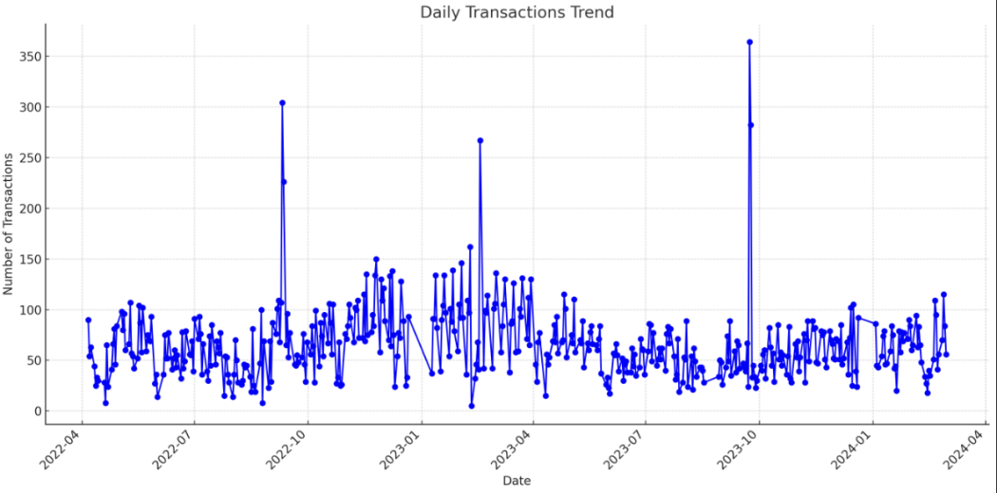

This chart shows the trend in the number of daily trades. By plotting these numbers on a line chart, we can see when the cafe is busiest and predict how busy it will be in the future.

**Predicting Future Sales**

Use a linear regression model to predict the number of entering customers over the next few days. Convert the date to the number of days from the start date and use this as an independent variable (X) to predict the number of transactions (Y).

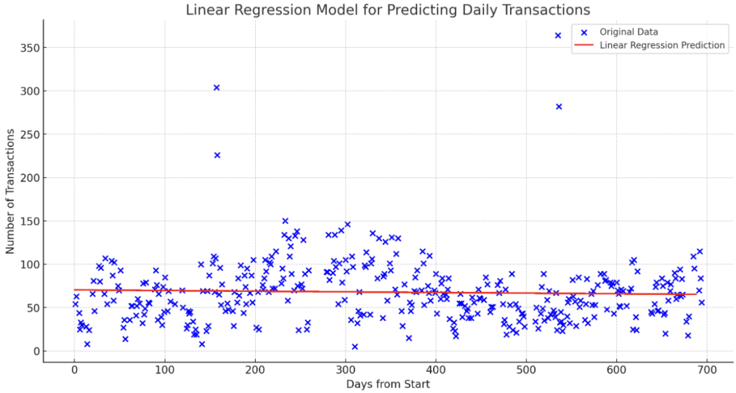

This graph shows the raw daily transaction data and the results predicted using a linear regression model. The blue points represent the actual number of transactions in the dataset, while the red line represents the model’s prediction of the number of future transactions.

While linear regression provides a basic trendline to predict future trade volume, real life can be unpredictable. Special events or holidays can make the cafe busier or quieter than usual.

**Visual analysis of daily transaction volume**

By analysing the number of daily transactions and predicted future transaction trends for this coffee shop, we can see that the coffee shop is showing a positive trend in growth and popularity. This shows that the coffee shop successfully promotes the happiness of community members and significantly enhances its local influence by providing high-quality services and a comfortable environment. This growing trend reflects the success of the coffee shop in meeting customer needs and creating positive community spaces.

**By comparing the coffee shop’s daily transaction volume in the morning versus afternoon and on weekdays versus weekends**,

we observed a significant increase in transaction volume in coffee shop during weekday afternoons and weekends, indicating that community members tend to use coffee shop as a place to relax and socialize after get off work and on weekends. This trend not only reflects the role of the coffee shop in meeting the daily relaxation needs of community members, but also indicates their potential to enhance community vitality.

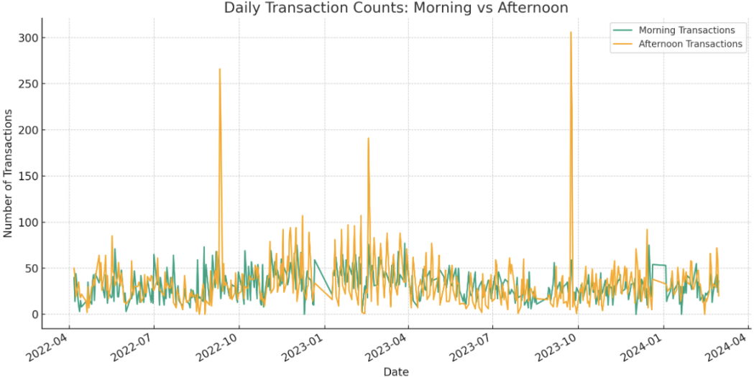

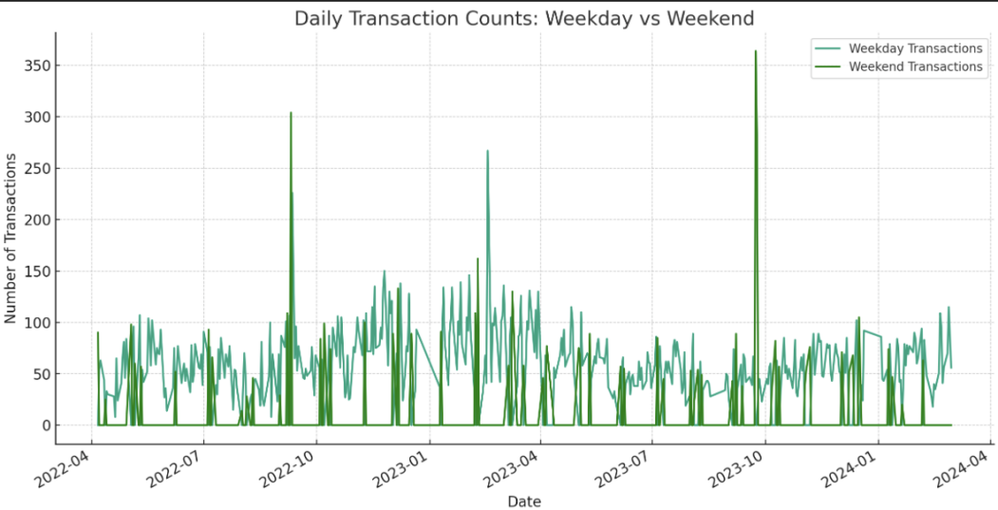

**What does the coffee shop do in promoting community well-being?**

1. ***Increase Social Activities:***

The coffee shop serves as a gathering place for the community, providing a space for people to rest and socialize. Comparing the transaction volume between weekdays and weekends, it can be seen that the coffee shop is more attractive on weekends. This may be because people tend to gather with family and friends for social activities on their days off. Therefore, the coffee shop becomes an important place to promote social interaction among community members and strengthen community cohesion.

1. ***Promote Emotional Connection:***

Community coffee shop provides not only coffee and meals, but also a place to relax and enjoy life. Judging from the time distribution of the number of transactions, the transaction volume in the morning and afternoon shows people’s need to find such experiences in their daily lives. The coffee shop has played a positive role in improving the emotional well-being of community members by becoming a place to escape from daily stress and enjoy a quiet moment over a cup of coffee.

1. ***Promote Physical Health:***

Offering delicious coffee and a relaxing atmosphere, the coffee shop contributes positively to customers' physical and mental well-being.

**Conclusion**

Based on the analysis and prediction of the daily transaction volume of coffee shops, it can be seen that coffee shops provide community members with more than just a cup of coffee, but also a space that promotes emotional communication, social connection, intellectual inspiration, physical relaxation and environmental improvement.

By implementing the above strategies, coffee shops can further enhance their influence as community hubs, contributing to the overall development of the community and the well-being of its members.

**Impact Reporting for Toddler Group Dataset**

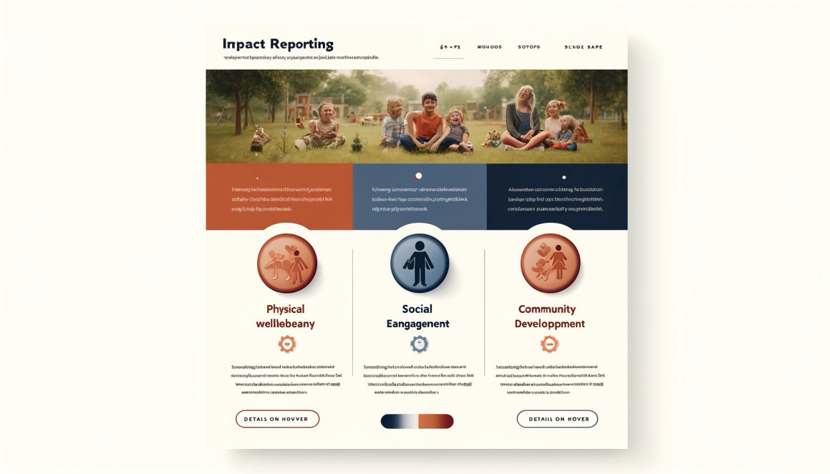

**Introduction**

Community activities like BS3 Toddlers and TAGG are crucial for fostering a vibrant community spirit, offering residents opportunities to connect, learn, and grow together.

**Attendance Analysis**

The BS3 Toddlers event is particularly popular, demonstrating strong community participation. The growth in TAGG attendance also shows that new activities can successfully engage community members.

**Time Trends**

The stable attendance at BS3 Toddlers events, alongside the rising interest in TAGG, indicates a healthy demand for community-driven activities among residents.

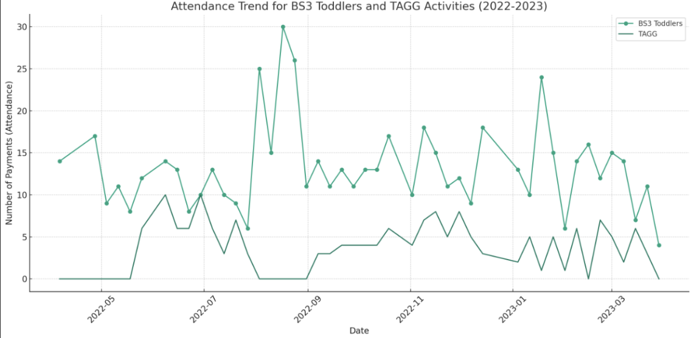

**Special Instructions Analysis**

Despite data recording challenges, it's evident that these toddler groups play a significant role in enhancing community cohesion and engagement.

**Key Aspects of Improving Community Impact**

***Social***

By participating in BS3 Toddlers' group events, community members have the opportunity to build and grow their social network. Especially for new families or members who have just moved to the community, these activities become a bridge for them to integrate into the community and make new friends. This social interaction is not limited to the duration of the event, but may extend to other aspects of the community.

***Intellectual***

The activities are designed to encourage participants to learn new skills and knowledge. For children, this may be developing basic cognitive and social skills through play and interactive activities. For adult participants, by communicating with people from different backgrounds, they are able to obtain new viewpoints and knowledge, which promotes intellectual development and communication.

***Physical***

Participation in community activities provides opportunities for active physical activity. For children, this is an important part of physical development and the basis for developing healthy living habits. Adult participants also improve their physical health by staying active through activities.

**Conclusion**

Through analysis of attendance at BS3 Toddlers group events, we can see that despite challenges and limitations, these events successfully promote the emotional, social, intellectual, physical and environmental development of community members. This shows that by continuing to support and develop such activities, community influence can be effectively improved and community cohesion and participation enhanced.

**Digital Inclusion Project Impact Report Structure**

**Introduction**

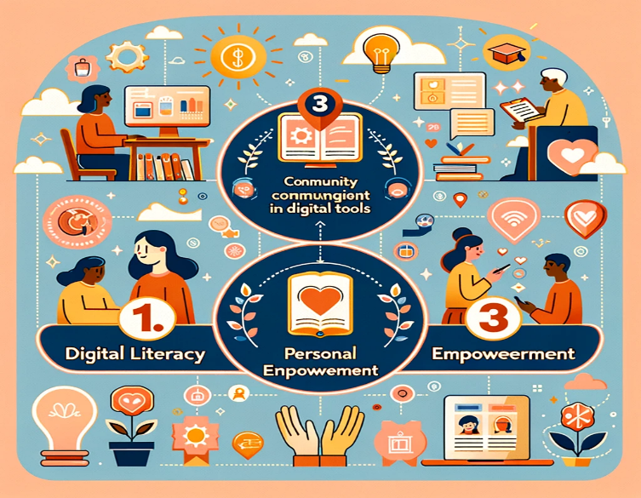

In the heart of Bristol, the BS3 Community Development's Digital Inclusion project, 'Connect with Ease,' has been making significant strides in bridging the digital divide. Launched in June 2023, under the guidance of Jacqui Ham and Head of Communities, Emmeline Rodman, this initiative aims to empower our community members with essential digital skills. From mastering basic online tasks to navigating the complexities of the digital world with confidence, **'Connect with Ease**' has transformed the way our community interacts with technology. By focusing on accessible learning and co-designing courses with participants, we have tailored our approach to meet the specific needs and interests of those we serve. As we reflect on the achievements of our courses and look forward to our next phase of drop-in workshops, we remain committed to fostering digital literacy and inclusion, ensuring everyone in our community can benefit from the digital era.

* Connect with Ease course 1 ran 11th Sept – 16th Oct 2023
* Connect with Ease course 2 ran 6th – 27th November 2023
* Last phase (year 1) Jan – March 2024.
* **Also mention the dates of the next phase at the right top with a link to apply/enquire**

**Impact Analysis:**

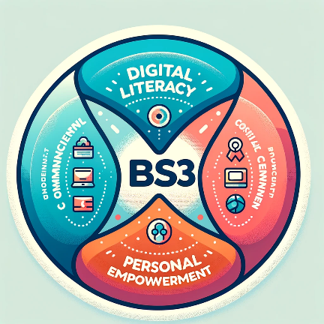

* The course types available (C1 & C2) and aim/goals can be mentioned and can be demonstrated in small tiles or blocks which will be clickable to see the whole details.
* At the top bubbles we can show KPI metrics based on people’s feedback of average change percentage of people taken the course which would also show success rate.
* Total no of people who completed the course so far can also be shown. Which shows how many people have been benefited **(70.5%).**
* Average of **96% change** was seen in people “confident using technology”.
* **95% change** was felt in people who believed “they could contribute to the society” post course.
* People felt safe using internet post course with **90% change rate**.
* There was **91% change rate** who felt they learned a new skill.

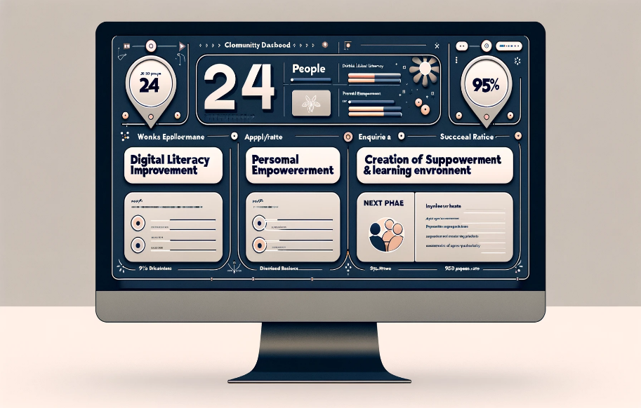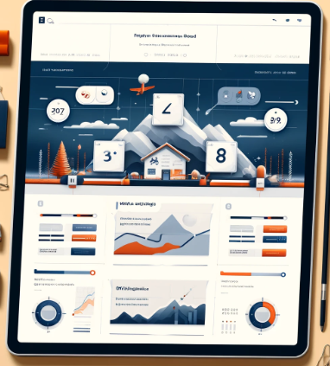

* **Digital Literacy Improvement:**

**Week 1:**

Tony: 2 (very anxious, significant worries about attending)

John: 3 (very quiet, but willing to learn)

Rita: 4 (social but has never attended any courses or worked before)

**Week 2:**

Tony: 4 (becomes more comfortable, appreciates the group's support)

John: 4 (keener to try, sends his first email)

Rita: 5 (enjoying the course, begins to engage more)

**Week 3:**

Tony: 5 (still worried but willing to buy online now)

John: 4 (learns about online shopping but still not confident)

Rita: 6 (gains confidence, learns new skills)

**Week 4:**

Tony: 6 (learns about apps, finds them useful)

Rita: 7 (gains more knowledge, starts exploring digital tools independently)

**Week 5:**

Tony: 7 (notices a decrease in fear of the digital world, feels more optimistic)

Rita: 8 (orders Wi-Fi for home, expresses desire to continue learning)

* ***Based on the weekly response from the case study, we can compare the week one response and final week response with infographics of each person. Where its clickable and will take you to another page to show every week response during the course.***

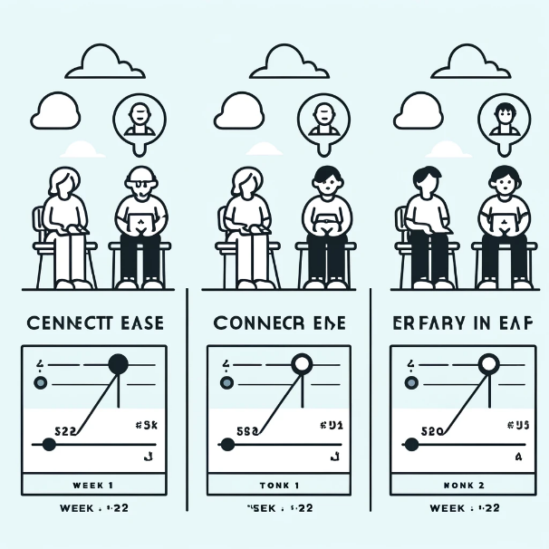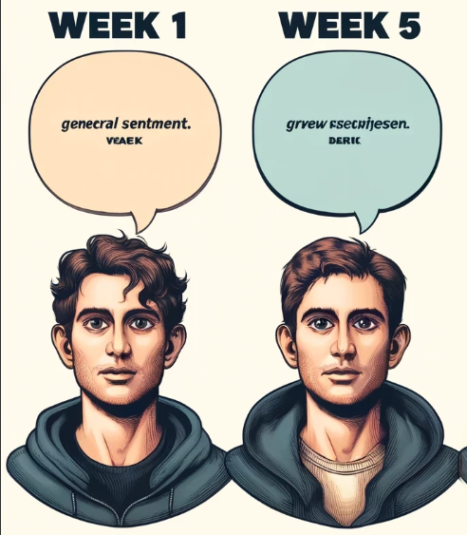



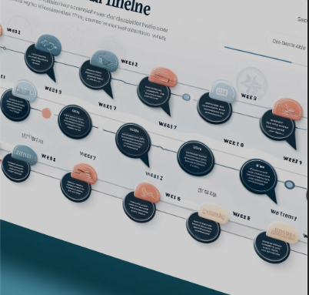

* **A SLIDER CAN BE PROVIDED WHERE THE BUBBLE QOUTES POP UP WHEN ITS SLIDED ON THE SELECTED WEEK. THIS CAN SHOW THE PROGRESS TIMELINE.**
* **Personal Empowerment & Confidence:**

1. Improvement in Confidence and Skills:
2. *Overcoming Fear and Anxiety:*
3. *Engagement with Digital Tools:*

* ***Creation of Supportive Learning Environment (comm support):***
* The establishment of a friendly group of mature students, as described by Tony, where participants felt confident to interact and support each other, further facilitated personal empowerment among the course attendees.
* iPads are provided by the charity for people to learn as per their convenient.

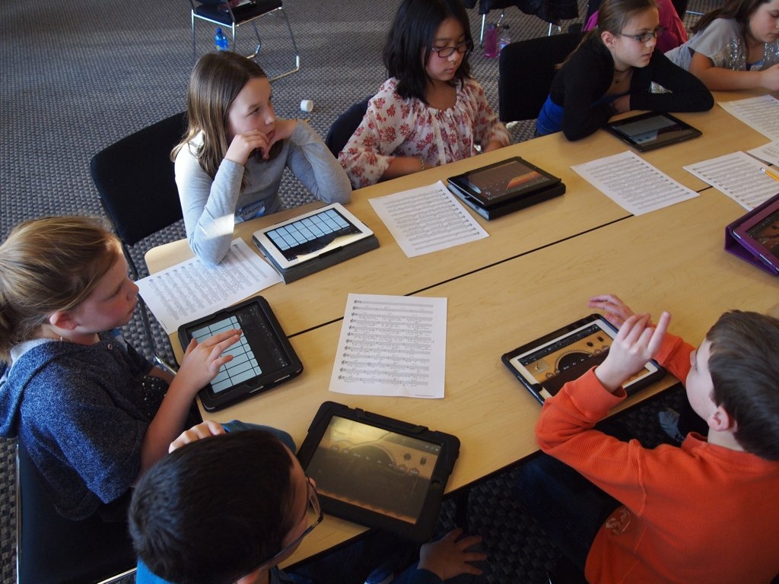

[This Photo](http://www.flickr.com/photos/56155476@N08/6660001925/) by Unknown Author is licensed under [CC BY](https://creativecommons.org/licenses/by/3.0/)

***Feedback on Personal Growth:***

Post-course feedback highlighted participants' increased understanding and confidence quotes like "This course has given me more understanding and confidence..." and "Definitely a confidence booster" and “I bought my first Christmas Present online “reflect the personal empowerment aspect of the course.



* We can show all the post feedback and responses in the bottom of the page which assures that these courses can be trusted and relied on as many people have seen improvement through these courses.

**Impact Reporting for Room Hire Data**

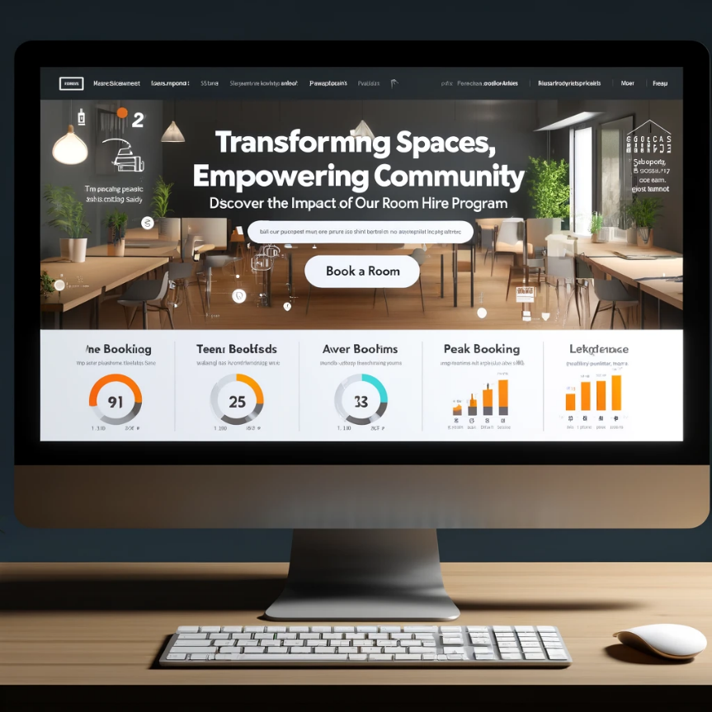

* ***Header draft***:

“Transforming Spaces, Empowering Community: Discover the Impact of Our Room Hire Program”

* ***Call to Action (CTA***) button on right top: include clear CTAs such as “Book a Room,” “Donate,” or “Get Involved.”
* ***Introduction draft:*** At BS3 Community, our fundamental aim is to cultivate a thriving, interconnected, and supportive ecosystem within our community. This ambition led to the launch of our room hire initiative, designed to transform our spaces into hubs of collaboration, learning, and growth. More than just offering physical spaces, this program represents our dedication to sparking positive change, fostering relationships, and enabling community-led projects to thrive. Dive into the journey of how this initiative is making a significant impact, through the stories, achievements, and transformative experiences we've shared. Let's celebrate the collective difference we're making, together, at BS3 Community.
* **Use the pictures** of the rooms that are available and their locations in the city. (once the CTA is pressed)
* ***Use of infographic or graphs:*** the demand of the room type, peak booking hours and busiest days in a week can be shown.
  + 1. **Number of Community Events Hosted.**
    2. **A Energy meter / Donut chart showing the room usage (or) type of event e.g., educational, cultural, social, private functions.**

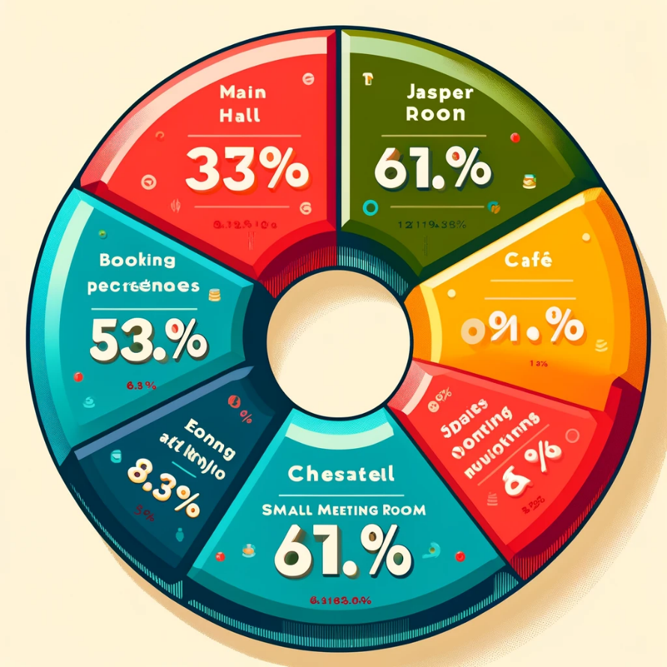

* + 1. **Repeat Bookings: which shows the consistency of people socializing through BS3 room events!**
    2. **Frequent event conducting by the charity to keep everyone engaging socially creating new connections.**

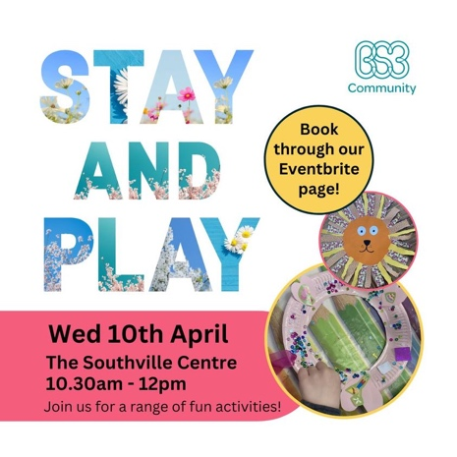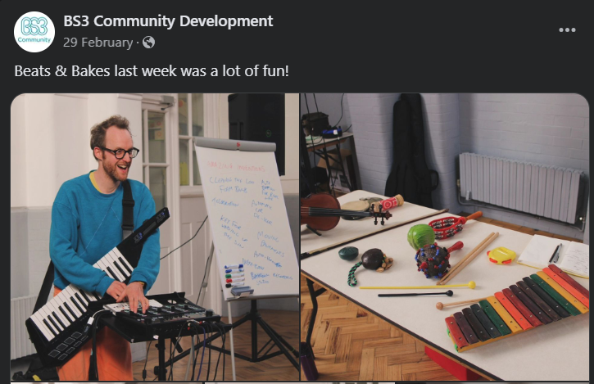

* ***Average bookings -*** 4 in a month (icon)
* ***Peak day in a week –*** Tuesdays, Thursdays, and Saturdays
* ***Most demanded room –*** Jasper room
* ***Paragraph draft – “why our rooms and how we impact the community?”***

At BS3 Community, our spaces are the heartbeat of cherished moments—where learning sparks bright futures, where families gather in celebration, and where every shared smile and promise sown becomes part of our collective memory. By offering our rooms for everything from classes to weddings, and at more affordable rates than elsewhere, we extend these opportunities to everyone in our community. Every event not only serves your needs but also supports our charitable work, as the money raised is reinvested into local projects. Choosing BS3 Community means you get value for your event while helping to strengthen the fabric of our neighbourhood. Every event you have with us, every joyful occasion, contributes to a greater cause, helping to make our community stronger and more vibrant with each booking.

* ***Footer***: Contact information, social media links, and a small section about BS3 Community's broader mission.

**Impact Reporting for Community Connectors Data**

**Project Overview:**

The BS3 Community Connectors Initiative aims to improve the wellbeing, health, happiness and connectivity of BS3 residents by providing them with a wide range of activities and support services. Our strategic approach is rooted in the values of 'positivity, inclusion and connection' and has been carefully designed to provide tailored opportunities through responsive mechanisms. Fundamental to this approach is listening to the voices of local communities in order to set programmed priorities and design content that resonates with residents.

**Impact Assessment:**

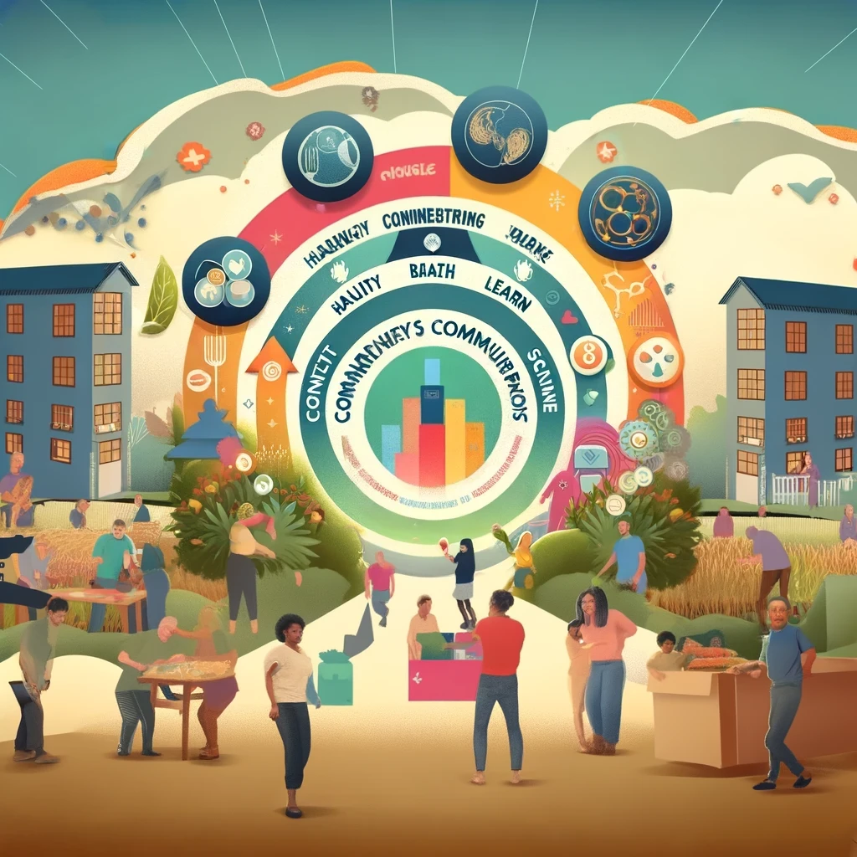

**Aims and Objectives:**

To strengthen community connections and intergenerational links:

Objective: To create an environment where people of all ages can have or participate in dialogue through diverse and targeted opportunities such as Community Connections, Events and School Room Cafes.

Outcome: Strengthened intergenerational links as evidenced by the participation of different age groups, including older people, with 3 participants aged 70+, 3 aged 80+, 5 aged around 65 and 8 aged around 60.

Output: Participation in gender-neutral activities such as technical workshops, community gardening and cooking classes aimed at breaking down traditional gender roles and promoting inclusiveness.

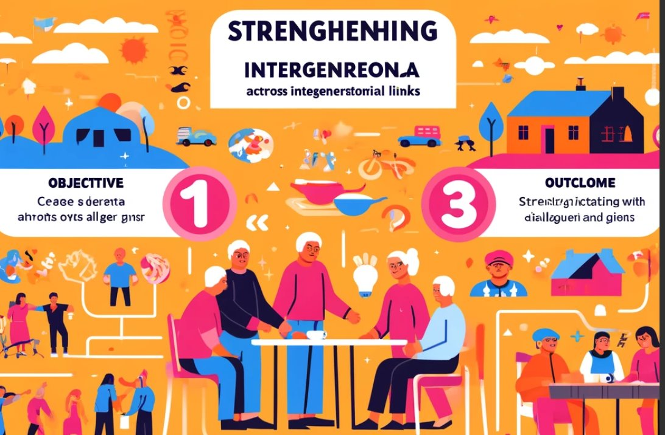

**Assess improvements in well-being and health:**

Goal: Promote wellbeing and health through responsive, community-led opportunities.

Objective: To utilise the Five Pathways to Wellbeing model (Connect, Be Active, Care, Learn, Give) to address personal health issues and provide support during a cost of living crisis.

Outcome: 9 participants reported improved health, highlighting the positive impact of community engagement on health.

Outcome: 14 participants continued to report health issues, highlighting the need for ongoing support and targeted interventions.

Active participation in community activities and learning:

**Goal:** Engage community members in a variety of activities that foster creativity, learning and health awareness.

**Objective:** Provide 7 different types of engagement activities including knitting classes, art groups, darts groups and an LGBT+ cafe to cater for a wide range of community interests.

**Outcome:** The community is more actively engaged in learning and creativity, with activities such as community arts festivals and health events demonstrating the commitment of the initiative.

**Outcome:** A wide range of different groups in the community are engaged, ensuring inclusive and diverse participation.



Types of Support

**Impact Reporting for Event Sales Data**

**Overview**

This report presents a comprehensive analysis of sales data associated with BS3 community events. It aims to understand the sales performance, event popularity, and pricing strategies to evaluate the overall impact of these events on the community.

**Total Sales Performance**

Total Gross Sales: The total gross sales from the events amounted to £3,273.91.

Total Net Sales: After deductions, the total net sales stood at £2,612.66.

These figures indicate a healthy interest and participation from the community in the events, reflecting positively on their impact and the community's willingness to engage in such activities.



**Event Popularity**

The analysis identified the top 5 events by tickets sold, highlighting the community's preferences and interests:

**Stay & Play:** 303 tickets sold, indicating a high level of interest in interactive and family-friendly activities.

**Christmas Trolls, The Little Things Theatre 11AM Show:** 80 tickets sold, showing a strong interest in holiday-themed theatrical performances.

**Christmas Trolls, The Little Things Theatre 2PM Show:** 74 tickets sold, further underscoring the popularity of theatre and festive events.

**Cosy Christmas. Carol Singing & Festive Film:** The Grinch: 72 tickets sold, indicating a preference for traditional holiday activities and entertainment.

**Cosy Christmas. Festive Films: Elf:** 64 tickets sold, highlighting the community's enjoyment of festive films as a group activity.

Popular events like Stay & Play and Christmas Trolls show success in bringing together people of all ages, enhancing communal bonds and intergenerational connectivity during festivals.Events like the Cosy Christmas activities encouraged active participation and learning within the community, aligning with the objectives of involving residents in community life and inspiring them to learn and be inspired.

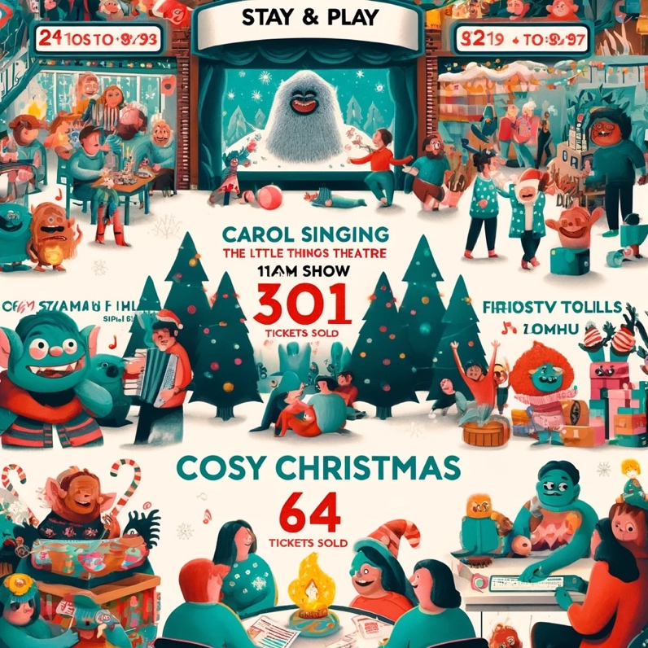

**Sales Over Time**

Sales figures varied significantly across different event dates, with the highest sales recorded on December 17, 2022 (£1,248.15). This suggests that events held during the holiday season tend to attract more attendees, likely due to increased availability and the festive mood within the community.

**Average Ticket Price**

The analysis of average ticket prices for the top-selling events provided insights into the pricing strategies employed. The average ticket prices ranged from £4.46 to £7.14, indicating a range of affordability that caters to different segments of the community. This strategic pricing likely contributed to the high sales volumes, making events accessible to a broader audience.

**Conclusion**

The BS3 community events have shown a positive impact on the community, with significant participation across a variety of events, especially those centered around family activities and the holiday season. The sales data reflects a successful engagement strategy, leveraging festive themes and inclusive pricing to maximize community involvement. Moving forward, focusing on these elements can further enhance community engagement and ensure the sustained success of future events.